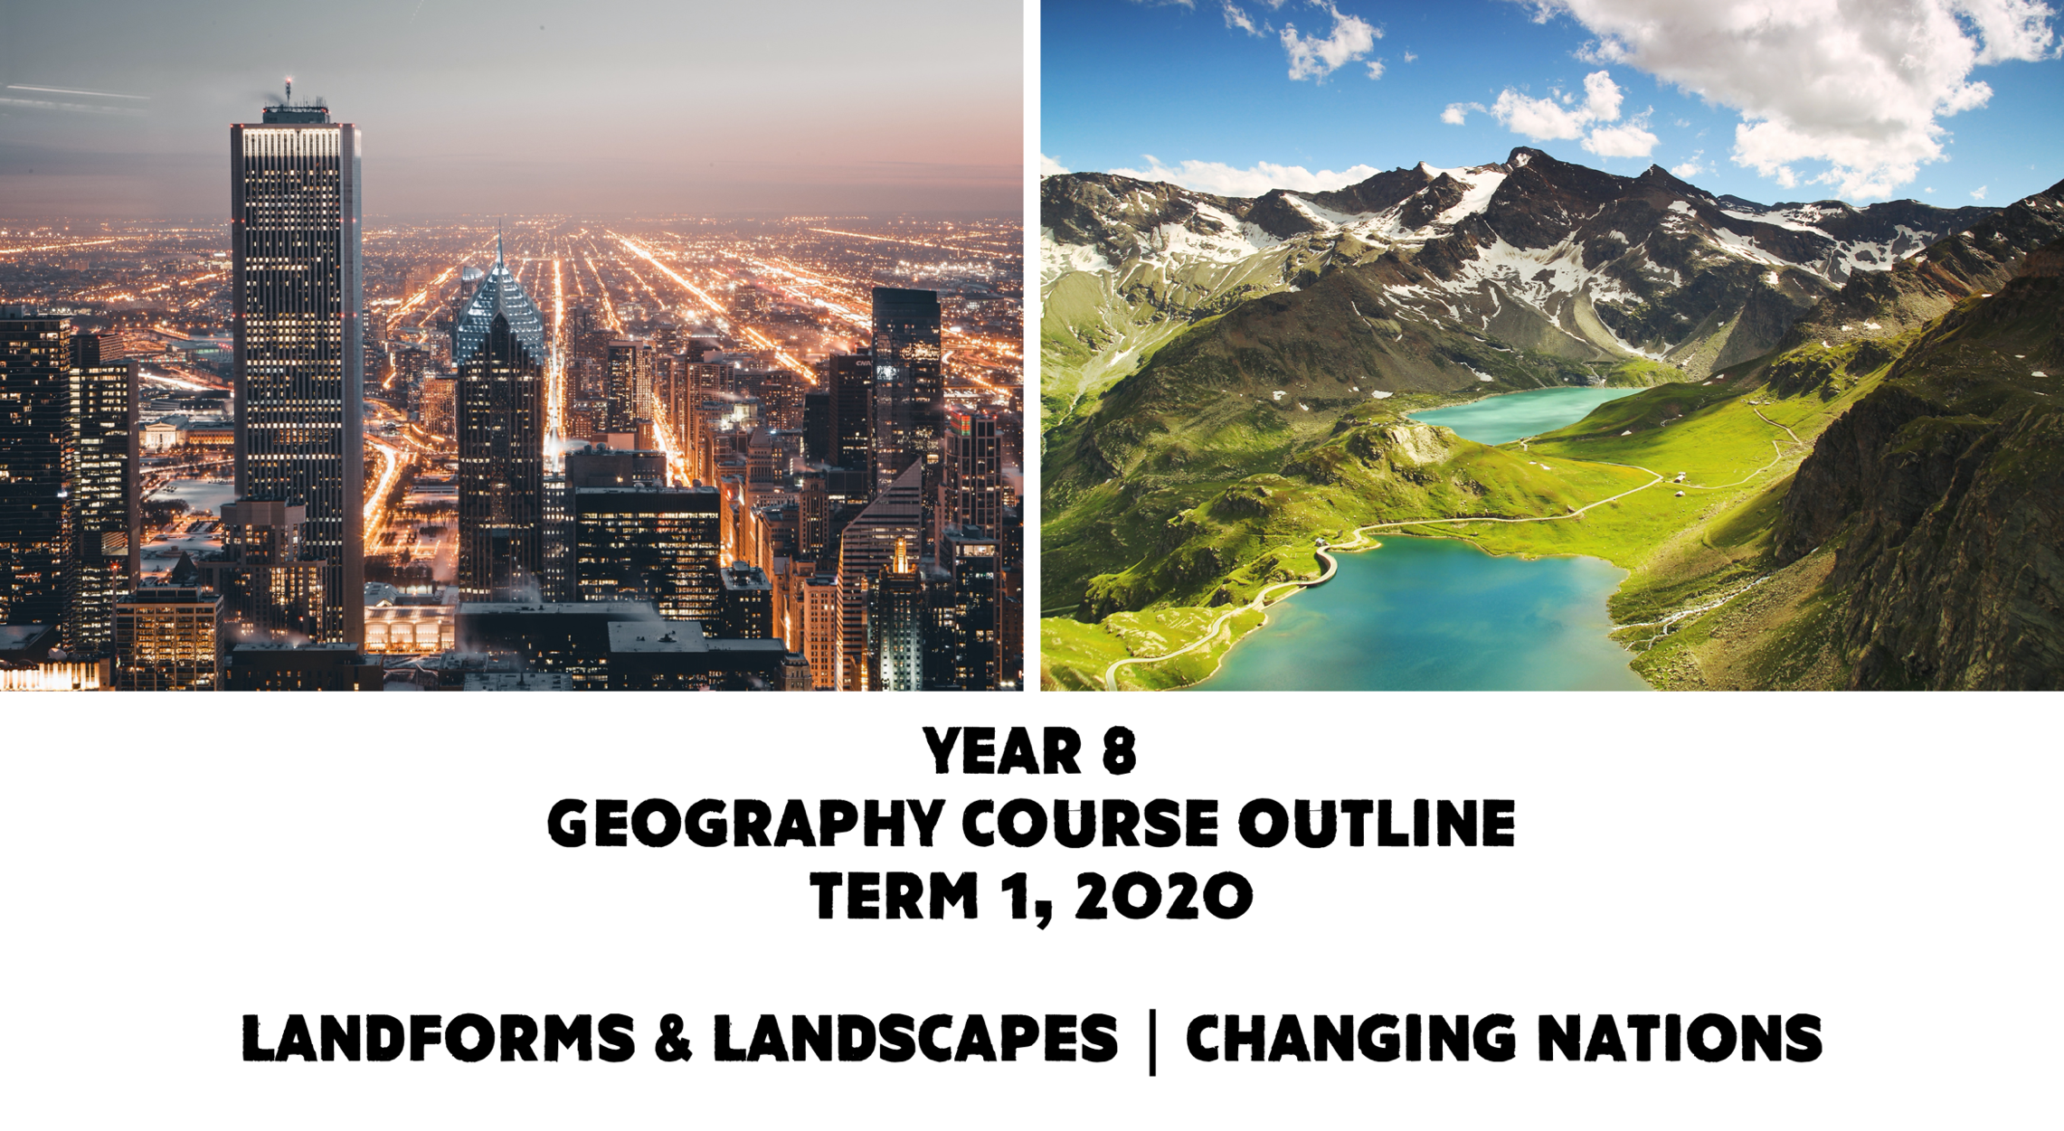

The concepts of place, space, environment, interconnection, sustainability and change continue to be developed as a way of thinking and provide students with the opportunity to inquire into the significance of landscapes to people and the spatial change in the distribution of populations. They apply this understanding to a wide range of places and environments at the full range of scales, from local to global, and in a range of locations. – SCSA
Prepared by R. Donavon, 2020

This course covers two strands: Geographical Knowledge and Understanding and Geographical Inquiry and Skills.

Landforms and Landscapes
- Focusses on investigating geomorphology through a study of landforms and landscapes.
- Examines the processes that shape individual landforms the values and meanings placed on landforms by diverse cultures, hazards, and management.
Changing Nations
- Investigates the changing human geography of countries
- The spatial distribution of population is sensitive to economic and social change and has significant environmental, economic and social implications.

Week 1 | Lesson 1 | Lesson 2 | Lesson 3 | Lesson 4
Course introduction: Unit 1 - Landforms and Landscapes
The different types of landscapes in Australia and their distinctive landform features (e.g. coastal, riverine, arid, mountain, karst) (ACHGK048)
Lesson Direction  Learning Intentions/  Success Criteria | School Wide Expectations Lesson  Ice breakers/classroom expectations | What is geography and why do we study it?  Discuss how the HASS skills would be used in geography.  Revise SPICESS.  Learning Intention:  Understand what geography is and why we study geography.  Success Criteria:  Can define what geography is and provide a brief outline of why we study geography. | Revise content from first lesson.  Introduction to landscapes  Define what a landscape is and discuss the four main elements that make up landscapes;  - Natural elements  - Living elements  - Human elements  - Changeable elements  Identify some iconic landscapes in Australia and the world, and describing what makes them iconic  Learning Intention:  Know what landforms and landscape are and the main elements which make up landscapes.  Success Criteria:  Can provide a brief definition of what a landform and a landscape is and can list the four main elements that make up landscapes. | Revise content from previous lesson.  Identify different types of landscapes, e.g. coastal, riverine, arid, mountain and karst, and describing examples from each in Australia.  Mapping activity – Australian Landscapes  Learning Intention: Know what landscapes are present in Australia.  Understand the different types of maps and the key features of a map.  Success Criteria: Can list examples of different landscapes found in Australia.  Can recall 3 examples of different types of maps and what BOLTSS stands for.
Suggested Resources | Refer to provided lesson plan from Student Services | Introduction to Geography & SPICESS PowerPoint (HASSL learning area drive) | Lesson Plan – Introduction to Landforms & Landscapes (HASSL learning area drive)  Pearson HASS 8 pp.96-99 | Learning Area Drive: Landscapes PowerPoint & Mapping Activity Worksheet (to be finalised)

Week 2/3 | Lesson 1 | Lesson 2 | Lesson 3 | Lesson 4
Unit 1 - Landforms and Landscapes
The geographical processes that produce landforms, including a case study of one type of landform, such as mountains, volcanoes, riverine or coastal landforms. (ACHGK050)
Lesson Direction  Learning Intentions/  Success Criteria | Australia’s Landform Regions  - The Great Western Plateau  - The Central Lowlands  - Great Eastern Highlands  - Coastal Lowlands  Learning Intention: Understand that Australia has four landform regions.  Success Criteria: Able to identify Australia’s four landform regions, where they are and their characteristics. | Weathering, Erosion and Deposition  Explore the types of physical weathering;  - Temperature change  - Freeze-thaw action  - Organic action  Explore chemical weathering  Learning Intention:  Understand the different forms of physical and Chemical weathering.  Success Criteria:  Can outline the different types of physical/chemical weathering which exist and the effect that each type has. | Weathering, Erosion and Deposition  Explore the processes of erosion;  - Attrition  - Abrasion  - Corrosion  - Hydraulic action  Discuss the agents of erosion  - Water  - Weather  - Rivers  - Waves  - Wind  - Ice  Discuss the process of deposition.  Learning Intention:  Understand the different processes of erosion and the different agents of erosion.  Success Criteria:  Can outline the different processes of erosion. | The changing face of the earth  Introduce plate tectonics and how the earth’s plates have shifted over time.  Learning Intention:  Understand what tectonic plates are and the major plates that make up the earth.  Understand how the earth’s tectonic plates have changed over time.  Success Criteria:  Can explain what a tectonic plate is and can name two major tectonic plates.
Suggested Resources | Australia’s Landform Regions paragraph activity and mapping.  Learning Area Drive | Pearson 8  Summary Table on Learning Area Drive | Pearson 8  Summary Table on Learning Area Drive | Task:  “Plate tectonics worksheet”  “Plate tectonics jigsaw activity”

Week 4 | Lesson 1 | Lesson 2 |  | Lesson 3 | Lesson 4
Unit 1 - Landforms and Landscapes
The geographical processes that produce landforms, including a case study of one type of landform, such as mountains, volcanoes, riverine or coastal landforms. (ACHGK050)
Focus will be on one geomorphic process:
- the causes b) spatial distribution c) impacts d) responses to a geomorphic hazard (e.g. volcanic eruption, earthquake, flood, tsunami, landslide, avalanche) (ACHGK053)
Lesson Direction  Learning Intentions/  Success Criteria | Types of plate movement that exists  Explore the three types of plate movement that occurs;  - A convergent plate boundary  - A divergent plate boundary  (Collision  - A transform plate boundary  Learning Intention:  Understands the processes which tectonic plates move to form landforms.  Success Criteria:  Can list the three types of plate movement and can explain an example of landform formed by each tectonic force. |  | Types of plate movement that exists  Explore the three types of plate movement that occurs;  - A convergent plate boundary  - A divergent plate boundary  (Collision  - A transform plate boundary  Learning Intention:  Understands the processes which tectonic plates move to form landforms.  Success Criteria:  Can list the three types of plate movement and can explain an example of landform formed by each tectonic force. | Mountain building  The processes of folding and faulting how this contributes to the formation of mountains.  Learning Intention:  Understand how different types of mountains are formed by different tectonic process.  Success Criteria:  Can explain what folding is and the types of mountains that this process creates.  Can explain what folding is and the types of mountains that this process creates | Introduce Inquiry Task – Geomorphic Hazards  Earthquakes – Introduce the Natural Hazard  Learning Intention:  Understand what an earthquake is, what causes an earthquake.  Success Criteria:  Can define what an earthquake is and what causes an earthquake.
Suggested Resources | Pearson HASS 8 pp.104-107  “Plate Tectonics PPT”-LA Drive  Diagrams from PPT to label  https://www.youtube.com/watch?v=fzhPmemffII |  | Humanities Dimensions Pages 32 - 37  Tectonics Jigsaw Activity LA Drive  Oreo Tectonics activity LA Drive | Pearson 8 Page 108-109  GeoWorld 8 Page 92-93 (No class set) | Pearson HASS 8 pp. 114-115  https://www.youtube.com/watch?v=JrBaiPN6AW8

Week 5 | Lesson 1 | Lesson 2 |  | Lesson 3 | Lesson 4
Unit 1 - Landforms and Landscapes
The geographical processes that produce landforms, including a case study of one type of landform, such as mountains, volcanoes, riverine or coastal landforms. (ACHGK050)
Focus will be on one geomorphic process:
- the causes b) spatial distribution c) impacts d) responses to a geomorphic hazard (e.g. volcanic eruption, earthquake, flood, tsunami, landslide, avalanche) (ACHGK053)

Lesson Direction  Learning Intentions/  Success Criteria | Introduction to Earthquakes  Cause of earthquakes  How earthquakes are measured  Effects of earthquakes  Learning Intention:  Understand the spatial distribution and the impacts of earthquakes. the effects of an earthquake.  Success Criteria:  Can describe where earthquakes occur.  Can briefly outline the effects of an earthquake. | Earthquake Survival and Recovery  Learning Intention:  Understand the how to survive Earthquakes and how people can prepare for earthquakes.  Success Criteria:  Can describe strategies for survival during an earthquake hazard event, how people manage the risk of earthquakes (building design etc) | Earthquakes Case study  Learning Intention:  Understand the impacts of the Haitian and Chilean Earthquakes and Sichuan (China) Earthquake.  Success Criteria:  Can describe details about the Haitian and Chilean Earthquakes and Sichuan (China) Earthquake. |  |  | Book time for students to research for their assignment. You can choose when to book these lessons. Reminder assignments are due Week 10. We have agreed to give students 6 lessons in class. You can decide if you want to give students a lesson per week, or as a block or if you want to scatter this out. The next six lessons have been blocked out for research lessons. Research lesson – Earthquakes Inquiry
Suggested Resources | Humanities Dimensions Pages 38 – 43 | Geography Alive 8 pages 112 - 113 | Geoworld 8 – pages 124-125 (student photocopies will need to be made as there is NO class set of the textbook).  Geography Alive 8 – Pages 110 – 111 (Class sets available).

Week 6 | Lesson 1 | Lesson 2 | Lesson 3 | Lesson 4
Focus will be on one geomorphic process:
- the causes b) spatial distribution c) impacts d) responses to a geomorphic hazard (e.g. volcanic eruption, earthquake, flood, tsunami, landslide, avalanche) (ACHGK053)
Lesson Direction  Learning Intentions/  Success Criteria | Research lesson – Earthquakes Inquiry | Research lesson – Earthquakes Inquiry | Research lesson – Earthquakes Inquiry | Research lesson – Earthquakes Inquiry
Suggested Resources

Week 7 | Lesson 1 | Lesson 2 | Lesson 3 | Lesson 4
Unit 2 - Changing Nations
The causes and consequences of urbanisation in Australia and one other country from the Asia region (ACHGK054)
The reasons for, and effects of, internal migration in Australia (ACHGK056)
Lesson Direction  Learning Intentions/  Success Criteria | Learning Intention:  Understand what urbanisation is and reasons why people move from rural areas to Urban Areas.  Success Criteria:  Can give a basic definition of Urbanisation.  Can list three causes of Urbanisation  Urbanisation  Define urbanisation and discuss examples.  Reasons why people move from rural areas to urban areas.  Numeracy and mapping skills: Use mapping skills to look at populations living in urban areas in a range of countries/Australia. Use statistics to create graph/table. Students identify components of maps (BOLTSS)  Introduce and define the following:  - Urban Growth  - Push and pull factors  - Mega city  - World City | Learning Intention:  Understand the impacts that urbanisation has on developed and less developed nations.  Success Criteria:  Can name the 5 effects of Urbanisation and briefly describe each.  Impacts of Urbanisation  Ways that Urbanisation impacts more developed and less developed nations;  - Migration of young people and young families.  - Families forced to split-up  - Carbon emissions  - Urban heat island effect  - Water consumption | Learning Intention:  Understand the main reasons why people in Australia move from rural areas to rural areas.  Success Criteria:  Can explain at least two reasons why people in Australia move to Urban areas.  Urbanisation in Australia  The main patterns and trends of Urbanisation in Australia.  The effect of resource development on employment growth in both the resource regions and the cities, and on internal migration in Australia. | Learning Intention:  Understand the main reasons why people in Australia move from rural areas to rural areas.  Success Criteria:  Can explain at least two reasons why people in Australia move to Urban areas.  Australia: Internal migration  The reasons why people migrate within Australia. Causes and effects of internal migration in Australia.  Define the following terms;  - Urban Sprawl  - Regional centers  - Sea Change  - Tree Change  Numeracy and mapping skills:  Students create a graph (bar, line etc.) of statistics in source 8.2.2 on page 159 of Pearson 8.
Suggested Resources | Resource  Pearson: Humanities and Social Sciences 8 (Arends et al)  Pp: 153-157 | Resource  Pearson: Humanities and Social Sciences 8 (Arends et al)  Pp: 153-157 | Resource  Pearson: Humanities and Social Sciences 8 (Arends et al)  Pp: 158-159

Week 8 | Lesson 1 | Lesson 2 | Lesson 3 | Lesson 4
Unit 2 - Changing Nations
The causes and consequences of urbanisation in Australia and one other country from the Asia region (ACHGK054)
The reasons for, and effects of, internal migration in Australia (ACHGK056)
Lesson Direction  Learning Intentions/  Success Criteria | Learning Intention:  Understand the reasons for Perth’s population growth, areas in which growth is occurring and the infrastructure requirements caused by this growth.  Success Criteria:  Outline the reason for Perth’s population growth in between 2001-11.  Give two examples of suburbs that are currently experiencing growth.  Provide two examples of infrastructure requirements for Perth’s population  CASE STUDY: PERTH  In class focus on the population growth of Perth. Look at a map of the suburbs that make up Perth and analyse areas where Perth population growth is occurring. Case study should include a focus on Perth’s infrastructure needs. | Continue from previous lesson. | Learning Intention:  Understand the reasons why people migrate from one country to another and the categories each reason falls under.  Success Criteria:  Can list at least four reasons why people migrate internationally.  International Migration  Focus on who migrates and their reasons for migrating.  The main types of and patterns of international migration;  - Student migration  - Permanent migration  - Temporary labour migration  - Forced migration  - Family reunion | Catch up lesson.
Suggested Resources | Resource  Pearson: Humanities and Social Sciences 8 (Arends et al)  Pp: 160-163 | Resource  Pearson: Humanities and Social Sciences 8 (Arends et al)  Pp: 164-167

Week 9 | Lesson 1 | Lesson 2 |  | Lesson 3 | Lesson 4
Unit 2 - Changing Nations
The causes and consequences of urbanisation in Australia and one other country from the Asia region (ACHGK054)
The reasons for, and effects of, internal migration in Australia (ACHGK056)
Lesson Direction  Learning Intentions/  Success Criteria | Assessment 3: Documentary analysis ‘Megacities’  Begin watching documentary | Assessment 3: Documentary analysis ‘Megacities’  Finish documentary | In-class assessment  Assessment 3: Documentary analysis ‘Megacities’  Students are to answer a set of short answer questions related to the ‘Megacities’ documentary watched in class. |  | Learning Intention:  Understand the Push and Pull factors for immigration.  Success Criteria:  Can correctly name two push and two pull factors for immigration.  International Migration  Link to knowledge from the previous lesson and discuss push and pull factors of international migration.  Students copy down push and pull factors of immigration diagram.  Look at statistics of countries with the largest migrant populations and major movements of people for work.  Possible Task:  Students are to select one of the types of migration and take the perspective of a migrant. Students are to write a letter/postcard to a family member about their migration experience and the reasons why they migrated to their new country. They must consider both push and pull factors.
Suggested Resources |  |  |  |  | Resource  Pearson: Humanities and Social Sciences 8 (Arends et al)  Pp: 164-167

Week 10 | Lesson 1 | Lesson 2 | Lesson 3 | Lesson 4
Unit 2 - Changing Nations
The causes and consequences of urbanisation in Australia and one other country from the Asia region (ACHGK054)
The reasons for, and effects of, internal migration in Australia (ACHGK056)
Lesson Direction  Learning Intentions/  Success Criteria | Learning Intention:  Understand the push and pull factors for urbanisation in China.  Success Criteria:  Can name two push and two pull factors for urbanisation in China.  CASE STUDY: CHINA  Internal Migration in China  - Causes and consequences  - Rural-Urban migration  - The hukou system and shift in government policy  - Push and Pull factors  - Future projections | Revision of geography and HASS skills: | Assessment Task 4 | Catch Up lesson/Summer Carnival.
Suggested Resources | Resource  Pearson: Humanities and Social Sciences 8 (Arends et al)  Pp: 174-175, 176-179, 180-181

